**Project Design Phase-II**

**Data Flow Diagram & User Stories**

|  |  |
| --- | --- |
| Date | 12 October 2022 |
| Team ID | PNT2022TMID51373 |
| Project Name | Project - Smart Lender - Applicant  Credibility Prediction for Loan Approval |
| Maximum Marks | 4 Marks |

**Data Flow Diagrams:**

A Data Flow Diagram (DFD) is a traditional visual representation of the information flows within a system. A neat and clear DFD can depict the right amount of the system requirement graphically. It shows how data enters and leaves the system, what changes the information, and where data is stored.

**Smart Lender - Applicant Credibility Prediction for Loan Approval**

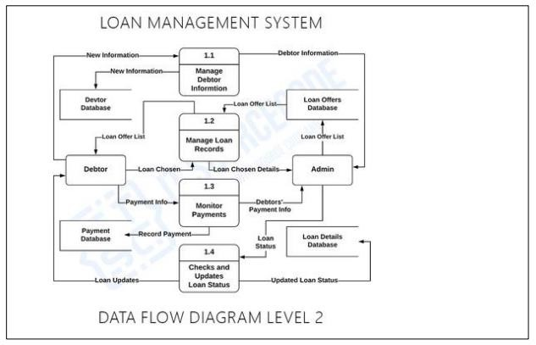

|  |  |  |  |  |  |  |
| --- | --- | --- | --- | --- | --- | --- |
| **User Type** | **Functional**  **Requirement**  **(Epic)** | **User**  **Story**  **Number** | **User Story / Task Release** | **Acceptance**  **criteria** | **Priority** | **Release** |
| Customer (Mobile user) | Registration | USN-1 | As a user, I can register for the application by entering my email, password, and confirming my password. | I can access my account / dashboard | High | Sprint-1 |
|  |  | USN-2 | As a user, I will receive confirmation email once I have registered for the application | I can receive confirmation email & click confirm | High | Sprint-1 |
|  |  | USN-3 | As a user, I can register for the application through Facebook | I can register & access the dashboard with Facebook Login | Low | Sprint-2 |
|  |  | USN-4 | As a user, I can register for the application through Gmail |  | Medium | Sprint-1 |
|  | Login | USN-5 | As a user, I can log into the application by entering email  & password |  | High | Sprint-1 |
|  | Dashboard | USN-6 | As a user, credit score can be checked | I can check my score by providing PAN | High | Sprint-1 |
| Customer (Web user) |  | USN-7 | As a user, I can interact with financial institutions |  | High | Sprint-2 |
| Customer  Care  Executive |  | USN-8 | As a user, I can solve my queries by interacting with helpline |  | Medium | Sprint-2 |

**User Stories**

Use the below template to list all the user stories for the product.

|  |  |  |  |  |  |  |
| --- | --- | --- | --- | --- | --- | --- |
| Administrat or |  | USN-9 | As a user, I can avail loans and credit from financial institutions | Credit score | High | Sprint-1 |